**27. Write a program to demonstrate how a timer is synchronized in JMeter.**

Synchronized timer:

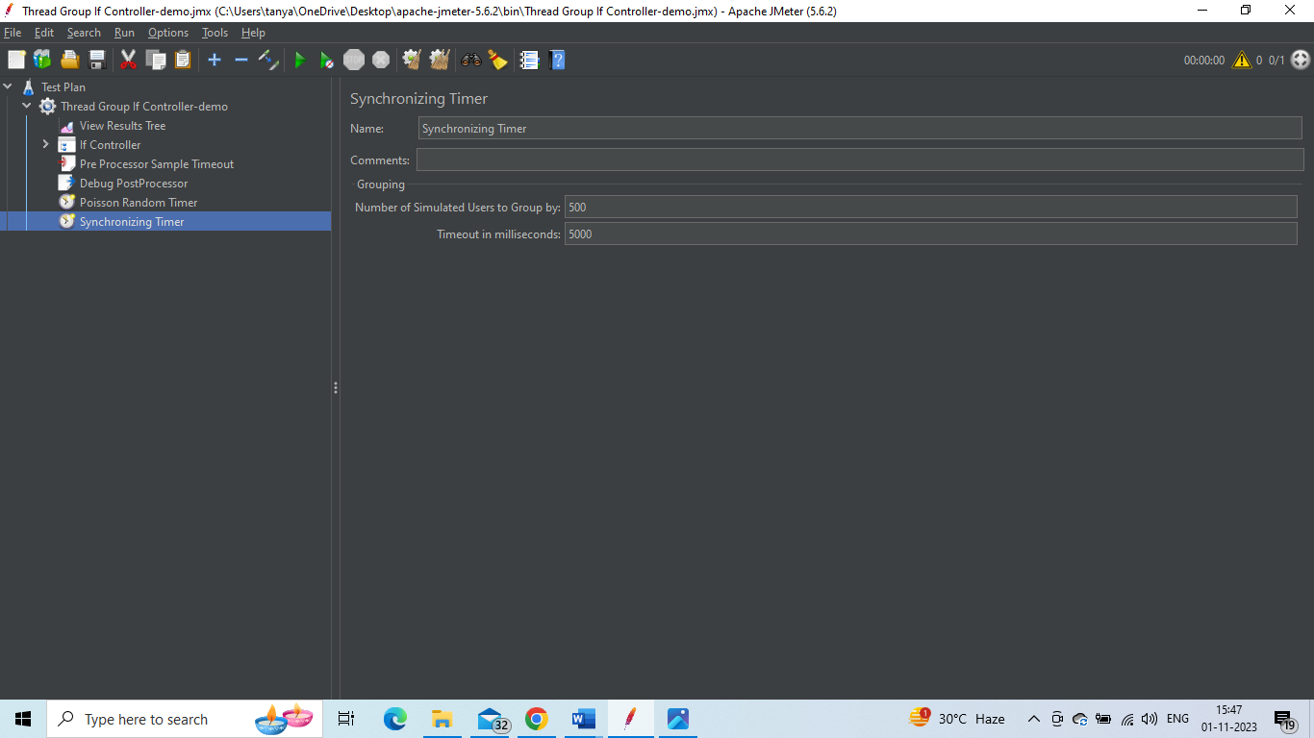

Constant timers:

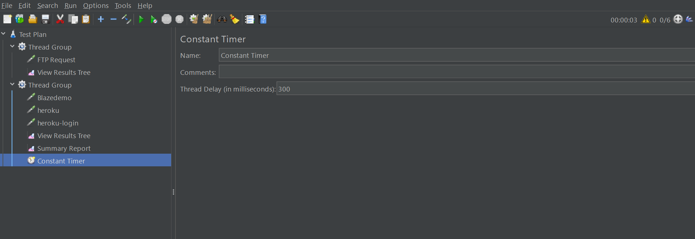

Uniform Random timer

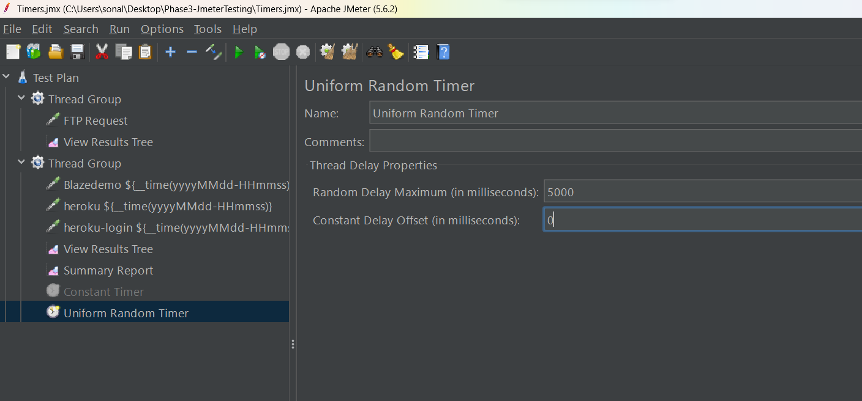

Gaussian Random timer

